National 5 Graphic Communication

3D Modelling
Revision Notes
National 5 Graphic Communication
3D Modelling Techniques and edits

At National 5 there are only 2 modelling techniques that you need to have a knowledge and understanding of:-
- Extrude
- Revolve
You may be asked to describe, using the correct 3D modelling terms how to create a particular model when given orthographic or pictorial views. It is very important that you use the correct terms otherwise you will lose valuable marks in the exam.
In addition to the modelling techniques mentioned above you must also have a knowledge and understanding of the following 3D modelling editing techniques:-
- Shell
- Subtract
- Fillet
- Chamfer
Extrude
Extrude is the most basic command in 3D modelling. It allows a designer to sketch a 2D shape and then “Extrude” the sketch by giving it a depth to turn it into a 3D shape.

2D Sketch 3D Extruded Model

The extrude command can also be used to “add” or “subtract” part of the original model.
Extrude (subtract)

Using Extrude (subtract) to create a hole through the 3D model.
Circle sketched on the top surface

Extrude (add)
Using Extrude (add) to create an addition to the 3D model.
Circle Sketched on the top surface
Revolve
Revolve is a powerful tool which is used to create 3D models which are cylindrical or conical. A 2D sketch is the starting point, which is then revolved around an axis to create the 3D model.

Axis

Profile revolved about axis through 360°
2D Sketch with axis shown

Other examples of objects which have been made using the revolve command are shown below.
Edits
In addition to the techniques outlined on the previous pages, you will also have to have knowledge of the following editing techniques.
- Shell
- Fillet
- Chamfer

Shell
The shell command is a tool designed to remove the inside material of a model and leave only a “wall” thickness. If an opening is required a face may also have to be removed.
Shell with top face removed
Shell with no face removed

Wall thickness
The two images above have been cut in half so that you can see inside.
Drinking tumbler that was revolved earlier now shelled with a 1mm wall thickness and top face removed.

Fillet and Chamfer
The fillet command is a tool which allows you to modify the edge of a 3D model. It is used to create a rounded edge by specifying the radius required.
The chamfer command is a tool which is used to create an angled corner.
Chamfer on four corners
Fillet on four corners
Example Exam Question
A CAD technician was provided with orthographic preliminary sketches of the wheel from a skateboard.

- Describe, with reference to correct dimensions and 3D CAD modelling terms, how you would use 3D CAD software to model the wheel.
You may use sketches to support your answer.
There is often more than one way to answer a 3D modelling question, using different modelling and editing techniques. Below are two different way of doing this.
I recommend using sketches and bullet point statements to help answer this type of question.
Revolve Solution  - Sketch a profile to the dimensions shown.  - Revolve profile about the axis through 360°.  - Fillet the two edges Radius 8.  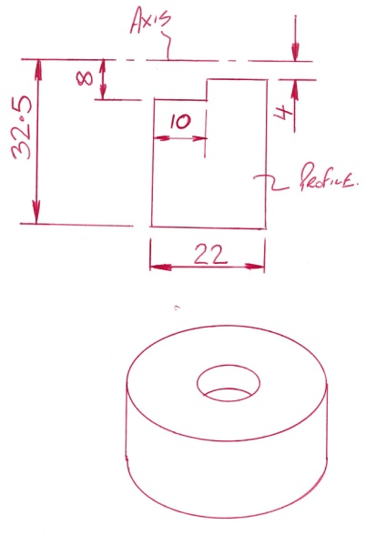  Fillet R8 | Extrude Solution  - Sketch Circle Ø65 and extrude by 22mm  - On top surface sketch circle Ø16 and extrude (subtract) by 10mm  - On bottom surface sketch circle Ø8 and extrude (subtract) by 12mm  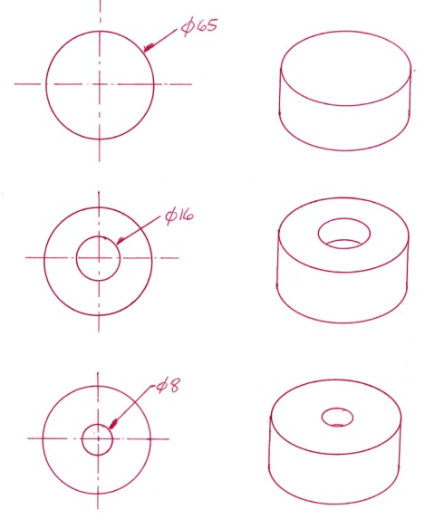  - Fillet the two edges Radius 8.  Fillet R8  1.  2.  3 + 4

Exam Style Question
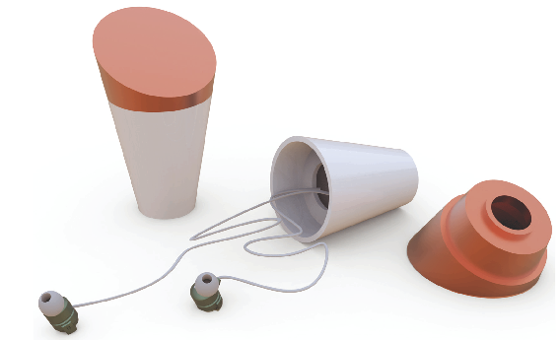
“Cone” is a portable container for storing earphones and other cable accessories.
The lid was modelled using 3D CAD modelling software.
(a) Describe, with reference to correct dimensions and 3D CAD modelling techniques, how the lid can be produced. Use the orthographic views below to help with your answer.
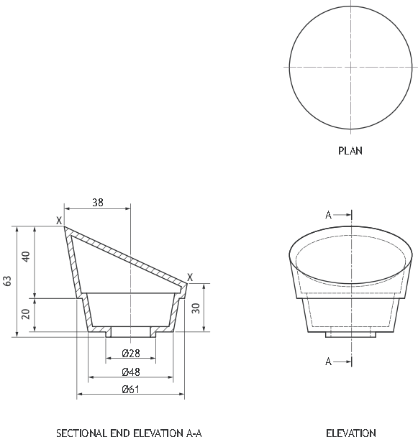
You may use sketches to support your answer.
Note: Wall thickness 3mm
Hidden detail omitted from plan for clarity

Exam Style Question
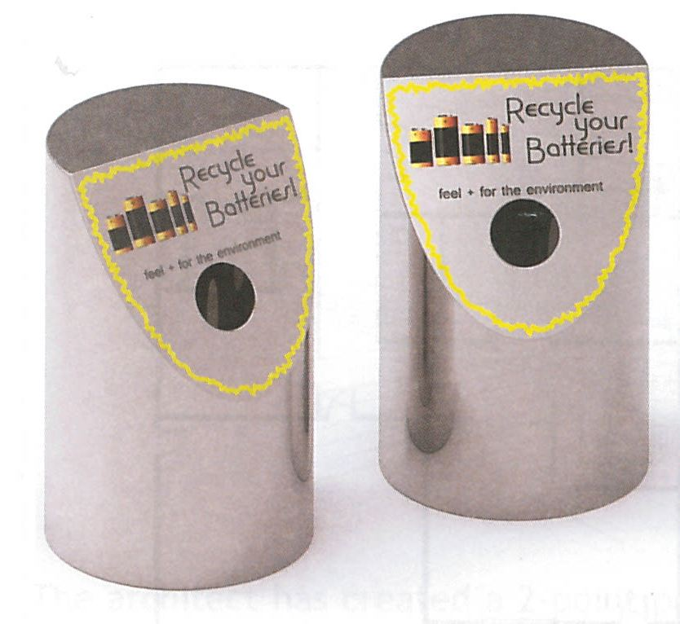
An environmental charity wants to encourage people to recycle old batteries. They employed a design engineer to make a “Battery Bin” where people could drop used batteries.
The graphic designer used 3D CAD to make a 3D model.
- Describe, using 3D CAD modelling terms, how the CAD model was created.
You may use sketches to illustrate your answer.
